1. 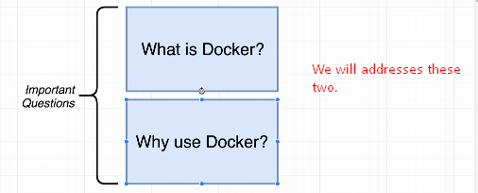
2. Let’s study why we use Docker by going through a quick little demo right now.
3. I’m going to show you a little flow diagram.
4. This is a flow of probably a process you’ve gone through at least once in your life before.  
   It is a flow of installing software on your personal computer and I bet at least once for this is what has happened.

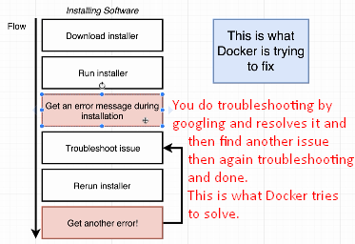

1. Docker makes it really easy and really straightforward for you to install and run software on any given personal computer or Web Server as well or cloud based computing platform.
2. I want to give you a very quick demonstration of this flow right here in action and then show you how quickly I can solve a problem of installing a piece of software by making use of Docker.
3. So, I get to very quickly go through the flow of installing a piece of software called red. It’s redis. Redis is in-memory Data Store. We’re going to be using it quite a bit throughout this course but right now I just want to give you a quick demo of how it can be a little bit challenging to get installed on your own computer.
4. Let’s go the installation steps very quickly.  
   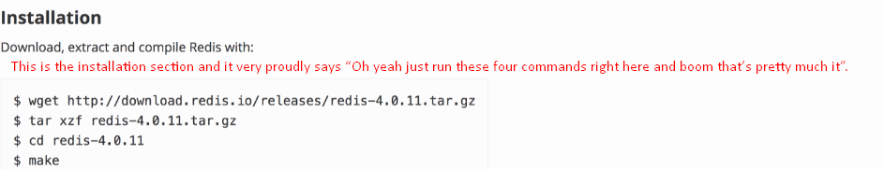
5. 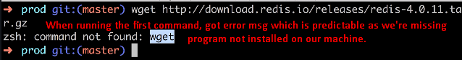
6. Now, we can troubleshoot this and install that program again but that is the whole point. You can get into this endless cycle of trying to do all this troubleshooting as you’re installing and running software.
7. Let me show you how easy it’s to run redis if you’re making use of Docker instead. 
8. 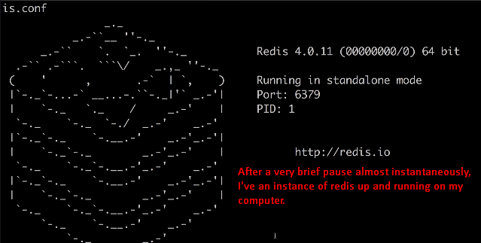
9. That is Docker in a nutshell that is how easy it is to run software when you’re making use of Docker. 